**DAC Interfacing with 8051**

* Microcontroller are used in wide variety of applications like for measuring and control of physical quantity like temperature, pressure, speed, distance, etc.
* In these systems microcontroller generates output which is in digital form but the controlling system requires analog signal as they don't accept digital data thus making it necessary to use DAC which converts digital data into equivalent analog voltage.
* In the figure shown, we use 8-bit DAC 0808. This IC converts digital data into equivalent analog Current. Hence we require an I to V converter to convert this current into equivalent voltage.
* According to theory of DAC Equivalent analog output is given as:  
  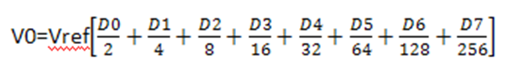  
  Ex:  
  1. IF data =00H [00000000], Vref= 10V 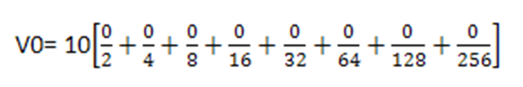

Therefore, V0= 0 Volts.  
  
  
2. If data is 80H [10000000], Vref= 10V 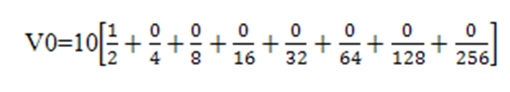 Therefore, V0= 5 Volts.  
  
Different Analog output voltages for different Digital signal is given as:  
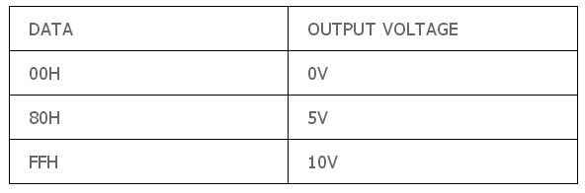  
  
**Interfacing Diagram**

